**The Business Environment**

|  |  |
| --- | --- |
|  |  |

# Business environment refers to the different forces or factors that affect business operations. Such forces include customers, competitors, suppliers, distributors, industry trends, government regulations, political activities, the economy, demographics, and social and cultural factors that operate within the area of the business. Others are innovations/ new creations and technological developments. These factors can be broadly divided into internal and external factors which interact in various ways to influence a [company's](http://www.businessdictionary.com/definition/company.html) [operating](http://www.businessdictionary.com/definition/operate.html) situation and can determine whether it succeeds or fails. The external factors are usually out of the control of the entrepreneur who can only adapt to them while the internal factors can be influenced succefully by the entrepreneur.

The business environment here means all of the **internal** and **external** factors that affect how the business functions. It is important to note that the process of starting up and developing a business is not just an adventure, but also a real challenge that requires one to scan carefully the environment in which they seek to operate since most of these factors mentioned above are not at the control of the entrepreneur. In order to spur entrepreneurship and ensure more businesses not only survive but thrive, it is essential that the government and other stakeholders too take cognizant of this and create a favorable business environment within the country. This includes ensuring easier access to funding, making legislation clearer and effective and developing an entrepreneurial culture and support networks for businesses to grow to their full potential.

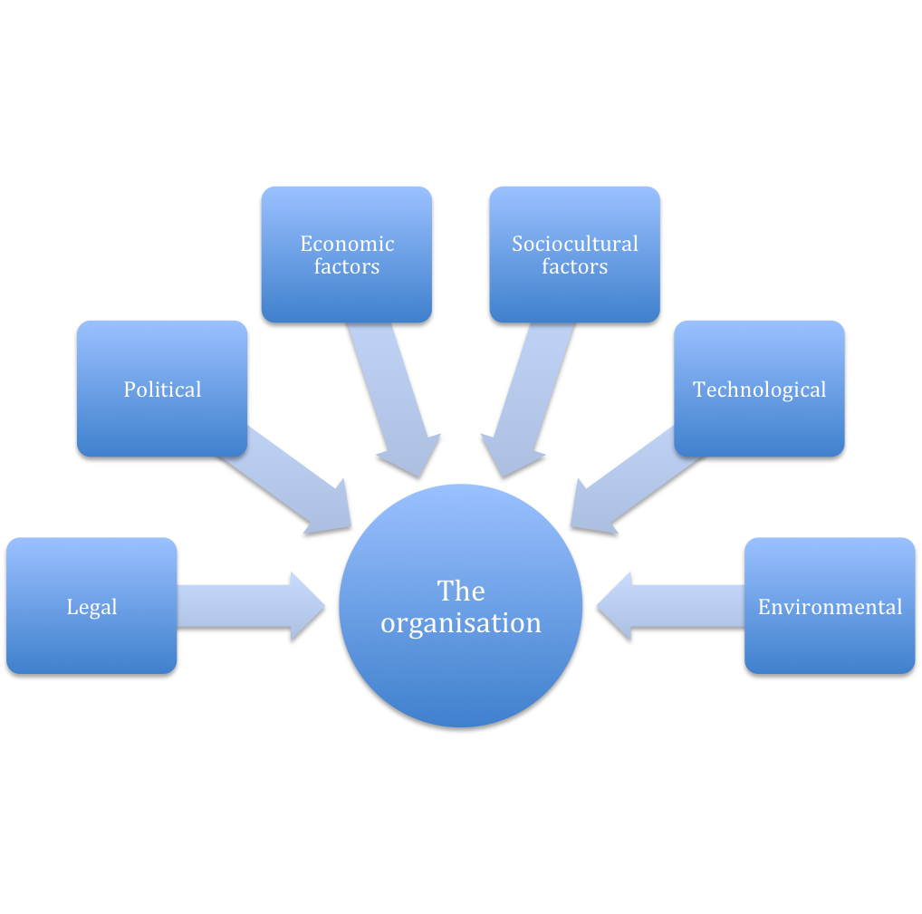

**Factors that affect a business environment.( Macro)**

The characteristics of a modern business environment includes globalization-.i) Globalization describes the process by which regional economies, societies and cultures have become integrated through a global network of political ideas through communication, transportation and trade; ii) Technology- traditionally businesses were primarily product-centric where products were made and sold but now with technology comes factors like e-businesses with a greater focus on customers. Emerging e-business and mobile technologies and the greater availability of [broadband](http://www.slideshare.net/veenaanbu/an-overview-of-global-business-environment-in-a-nation)  and telecommunications means that all businesses must be willing and ready to adapt to these changes to avoid being left out. Other changes are in the social, legal, economic, physical or political environment all which can give or take away value from the organization (usually referred to as PESTEL). It is therefore very important for an upcoming business owner to be aware of the relevant factors in his area of choice and the way they can change in the future to affect his business operations.

At a more individual level other forces that may affect businesses include: These external factors include suppliers, competitors, customers and marketing intermediaries among others. While it is practically impossible to control forces outside the business, like economic conditions and what competitors do, it is still important to be aware of them and design internal structures and strategies to react to them in a more effective way.

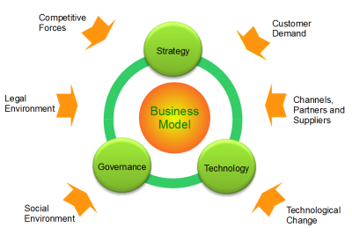

|  |  |
| --- | --- |
|  |  |

**Internal factors**

The internal business environment includes factors within the organization itself that impact the approach and success of your operations .these internal factors include the value system, the missions and objectives, and financial factors and availability of other resources like effective human resources

|  |  |
| --- | --- |
|  |  |
|  |  |

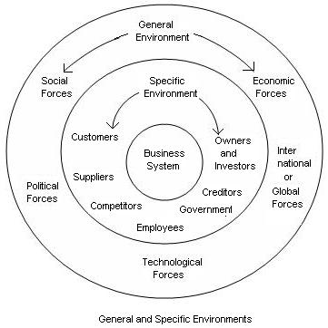

The external environment on the other hand consists of a variety of factors outside your company doors that you typically don't have much control over. [Managing](http://smallbusiness.chron.com/internal-external-environmental-factors-affect-business-69474.html) the strengths of your internal operations and recognizing potential opportunities and threats outside of your operations are keys to business success.

## Organizational Direction

The role of company leadership is an important internal business factor. Your leadership style and the styles of other company management impact organizational culture. The positive or negative nature, [level](http://smallbusiness.chron.com/internal-external-environmental-factors-affect-business-69474.html) of family-friendliness, effectiveness of communication and value of employees are cultural implications that result from leadership approaches. Companies often provide formal structure or direction with mission and vision statements. These are forward-looking statements that provide the guidance for company decisions and activities.

## Other Internal Factors

The strength of your employees commitment is another crucial internal business factor. Motivated, hard-working and talented workers generally produce better results than unmotivated, less-talented employees. Your [business processes](http://smallbusiness.chron.com/internal-external-environmental-factors-affect-business-69474.html) and relationships within and between departments and employees interactions with middle and top leadership significantly impact business effectiveness and efficiency. In a high-performing workplace, employees not only have talent, but they work well together and collaborate on ideas and resolutions.

## External forces

One of the most critical external business factors is competition. Whether you operate in a concentrated industry with a few major competitors or a large industry with many small competitors, you need to know the competition very well. Many companies do competitive analysis to compare their offerings and prices to those of competitors. When [developing](http://smallbusiness.chron.com/internal-external-environmental-factors-affect-business-69474.html) business philosophies and products, it is helpful to use your strength in quality production, customer service or operational efficiency to build competitive advantages that benefit your customers and that cannot be easily copied by your competitors.

## Other External Factors

Other common external factors fall into several categories: socio-economic, legal or ethical, political and technological. Socio-economic factors relate to the values, attitudes and concerns of your target customers and their economic abilities to afford your products. The legal and political environments generally relate to your need to abide by business laws, rules and regulations that can end up in litigation against you if flouted, ethical or social aspect refer to your own responsibility towards your customers and communities which even though not written, is still expected for you to maintain some standards so as to earn your license to operate. In some industries, technological evolution drives the need for companies to adapt and constantly [research](http://smallbusiness.chron.com/internal-external-environmental-factors-affect-business-69474.html) for improvements and keep up with rapid changes in the global environment eg. In the IT industry.

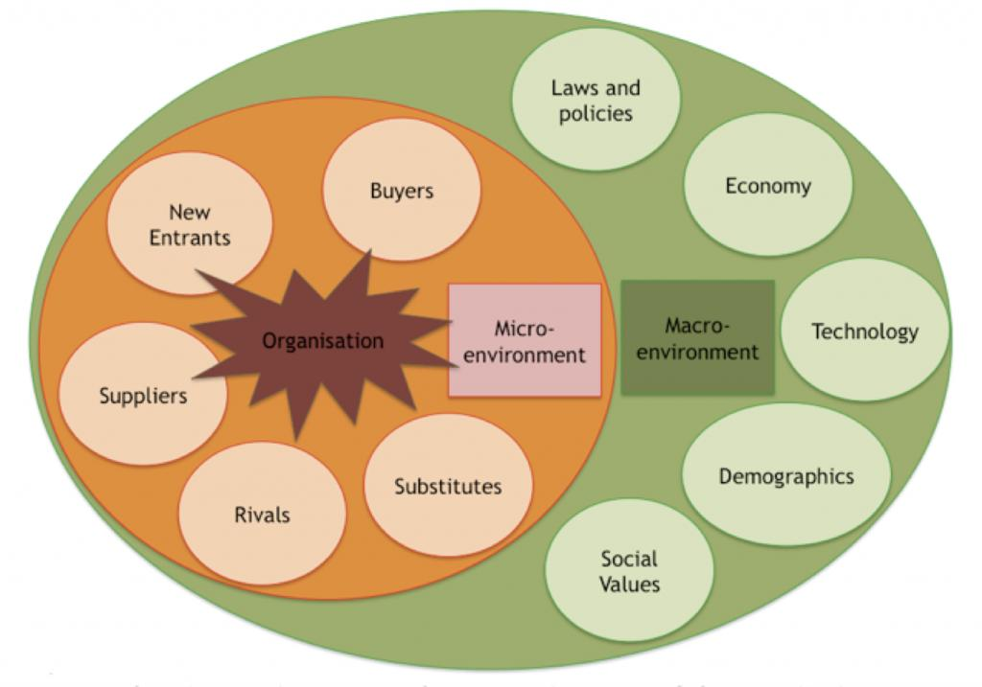

**The Global Business Environment**

In 2010, the global financial system remained fragile, but economies around the world began moving toward recovery. Some — especially those in emerging markets — hardly broke stride, continuing their rapid growth.

The report, [*Tracking*](http://www.ey.com/GL/en/Issues/Business-environment/Six-global-trends-shaping-the-business-world)global trends, looks at six broad, long-term developments that are shaping our world today:

1. [Emerging markets increase their global power](javascript:generic_link_WT('/GL/en/Issues/Business-environment/Six-global-trends-shaping-the-business-world---Emerging-markets-increase-their-global-power',%20'/GL/en/Issues/Business%20environment',%20'Six%20global%20trends%20shaping%20the%20business%20world%20-%20Emerging%20markets%20increase%20their%20global%20power');)
2. [Cleantech becomes a competitive advantage](javascript:generic_link_WT('/GL/en/Issues/Business-environment/Six-global-trends-shaping-the-business-world---Cleantech-becomes-a-competitive-advantage',%20'/GL/en/Issues/Business%20environment',%20'Six%20global%20trends%20shaping%20the%20business%20world%20-%20Cleantech%20becomes%20a%20competitive%20advantage');)
3. [Global banking seeks recovery through transformation](javascript:generic_link_WT('/GL/en/Issues/Business-environment/Six-global-trends-shaping-the-business-world---Global-banking-seeks-recovery-through-transformation',%20'/GL/en/Issues/Business%20environment',%20'Six%20global%20trends%20shaping%20the%20business%20world%20-%20Global%20banking%20seeks%20recovery%20through%20transformation');)
4. [Governments enhance ties with the private sector](javascript:generic_link_WT('/GL/en/Issues/Business-environment/Six-global-trends-shaping-the-business-world---Governments-enhance-ties-with-the-private-sector',%20'/GL/en/Issues/Business%20environment',%20'Six%20global%20trends%20shaping%20the%20business%20world%20-%20Governments%20enhance%20ties%20with%20the%20private%20sector');)
5. [Rapid technology innovation creates a smart, mobile world](javascript:generic_link_WT('/GL/en/Issues/Business-environment/Six-global-trends-shaping-the-business-world---Rapid-technology-innovation-creates-a-smart--mobile-world',%20'/GL/en/Issues/Business%20environment',%20'Six%20global%20trends%20shaping%20the%20business%20world%20-%20Rapid%20technology%20innovation%20creates%20a%20smart,%20mobile%20world');)
6. [Demographic shifts transform the global workforce](javascript:generic_link_WT('/GL/en/Issues/Business-environment/Six-global-trends-shaping-the-business-world---Demographic-shifts-transform-the-global-workforce',%20'/GL/en/Issues/Business%20environment',%20'Six%20global%20trends%20shaping%20the%20business%20world%20-%20Demographic%20shifts%20transform%20the%20global%20workforce');)

Global economies are so tightly interconnected that companies, governments and industries will soon be forced to cooperate in ways they could not have imagined just a few years ago.

In fact, Ernst & Young believes the six trends are themselves connected by three underlying drivers that have helped establish each trend and perpetuate it.

1. **Demographic shifts.** Population growth, increased urbanization, a widening divide between countries with youthful and quickly aging populations and a rapidly growing middle class are reshaping not only the business world, but also society as a whole.
2. **Reshaped global power structure.** As the world recovers from the worst recession in decades, the rise of relationships between the public and private sectors has shifted the balance of global power faster than most could have imagined just a few years ago.
3. **Disruptive innovation.** [Innovations](http://www.ey.com/GL/en/Issues/Business-environment/Six-global-trends-shaping-the-business-world) in technology continue to have massive effects on established business and society. We're now seeing emerging markets become hotbeds of innovation, especially in efforts to reach the growing middle class and low-income consumers around the globe.

#### Six global trends, interconnected by three key drivers of change

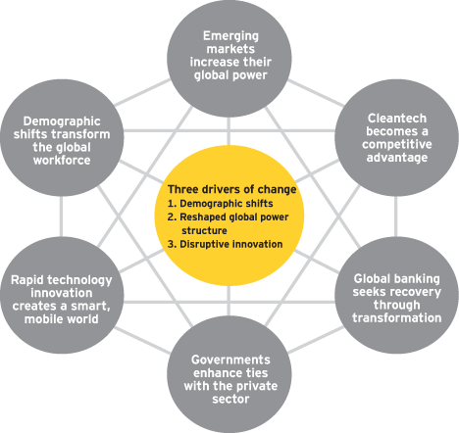

### Winner and losers

As these trends change the ways in which businesses operate, grow and compete; winners and losers inevitably will emerge. The winners will be easy to spot:

1. They will be the organizations that constantly monitor broad trends in the external environment, embrace technology and look for talent everywhere, especially among previously neglected segments of the workforce such as women, minorities and older workers.
2. Regardless of what industry they are in or where they are headquartered, these organizations are looking outward. In so doing, they are navigating multiple jurisdictions and regulatory frameworks while adapting to local environments and attempting to create global workforces.
3. They are modifying supply chains to leverage shifting labor cost structures and mitigate raw materials' price fluctuations.
4. They are figuring out how cleantech fits into their growth plans and making it an integral part of their future strategy.
5. National governments, meanwhile, are seeking ways to meet growth agendas while reducing cost structures and future debt obligations.

### Shaping the future

As businesses and governments look to the future, they would do well to remember that executing on their existing strategy may no longer be good enough. They must think more deeply about the opportunities and risks presented by the evolving trends, and the driving forces behind them.

With a different mindset, they can re-imagine what is possible, discovering what they can do that is new, and how best to do it. Those that succeed may find themselves not just navigating tomorrow’s global trends, but actually shaping them.